# Developer Handbook

## Legal notice

Please be aware that this application is only a student-designed application. Team members are not responsible for any harm or damage caused by usage of this application or anything else.

## Introduction

This developer handbook is designed to pass knowledge about the customer application from ToMartin. The application is designed to handle simple customer management with a small, file-based database.

## Changes

V 1.0 Optimized for memory- usage

Each instance of a form is disposed after usage. Temporary variables for usage of fields/members of a variable are replaced by directly accessing the field/member.

## Structure of the customer application

The customer application consists of several components. It is divided into a main form where you can select from a list of customers, create a new one or change balance from a customer, a edit window where you can enter data for a new customer, change balance of an existing customer or change data for a existing customer and a login window which controls access for the application. For security reasons the data is not stored in plain text but encrypted. The decryption/encryption is implemented in main form for reading and writing a customer database because this is only used there.

The basic inner structure can be seen in the interface description. All windows use the class Customer.

--Class Diagram???????----

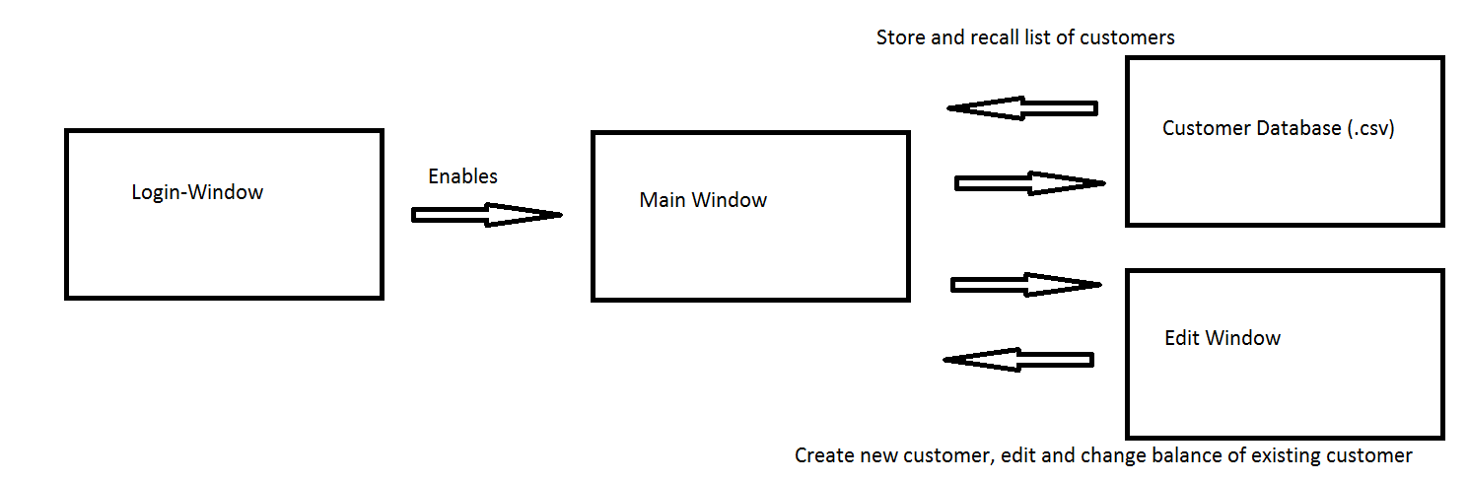

--bitte entschuldigt die schlechte Zeichnung! Ich habe nur Paint zur Verfügung

## Dynamic behavior

--Sequence-Diagram!!! (hatte kein Visio)----

## Component description

Class Customer 🡪 Interface description

Main Window 🡪 Main GUI, interacts with the database. Is described in the document  
 ‘Interface description’

Login Window 🡪 Is designed to handle security. Only users with the correct password are allowed to   
 enter the application

## Data Format

The main database is a .csv-file. It has an encrypted content to avoid insight without permission. For all components C#-standard data formats are used.

Final tests

|  |  |  |  |  |
| --- | --- | --- | --- | --- |
| Test number | Precondition | Input | Expected output | What is tested |
| 1. | * App. not running | Start app. and login correctly | Main window is operating | * Correct startup * Connection Login-,Main window |
| 2 | * App not running | Start app and login incorrectly, afterwards press cancel | App should show a message for wrong pw an be closed at cancel | * Security |
| 2 | * App not running | Start the application with a known database | Database should be loaded | * Test decryption * Test correct loading of database |
| 3 | * App running database exists | Delete database | Database is created with next change (add, edit…) | * Correct store of database and file exception handling |
| 3. | * App. running * Main window operating * Database does not exist | Add a new customer | Database is created | * Correct initialization * Creating new database * Customer is listed in Main window and database * Correct startup of the Edit window * Connection Main-, Edit window |
| 5. | * App. running * Edit window operating * Database does exist and contains at least one customer * Customer has a positive balance | Lend money, save and close window, reopen the edit window with the same customer pay money and cancel | Balance of the customer changes once in the database and the main window but not twice | * Connection edit window, database, main window * Correct save and cancel * Correct editing the database * Correct calculation |
| 6 | * App running * Customer in database | Open edit window and close without change (button close) | Customer is not changed | * Correct abort of customer editing |
| 7 | * App running | Add a new customer, try to enter a email adress with no ‚@’ | Error should occur | * Correct handling of not-allowed inputs |

All test cases were tested before delivery on ….. by Martin Pachler (Junior developer @ ToMartin).

# Let’s get startet with ToMartin- Customer Application

## Installation

* 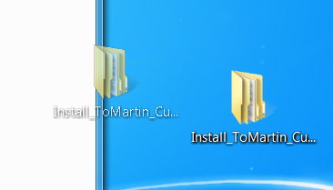Install the application by dragging the Install_ToMartin_Customer folder to a folder on your computer

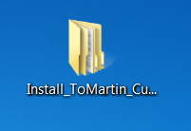

🡪

* Start the application by double-click the ‘CustomerManagement.exe’



* Every startup you have to enter your password. Please be aware to watch out that your password is not stolen or spied by anyone.

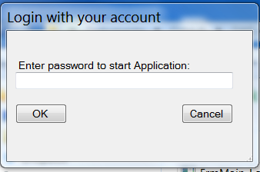

When you have entered your password correctly you can see the database. Now you can add and edit your customer database. For existing Customers you can change balance.

If you stuck you can drag your mouse over a control (e.g. a button). This shows you the **tooltips** which may help you.

## Database

Your database is stored in the same folder as the application. It is a .csv file named ‘cDB’ you can backup the customer database by copy this file and restore it by paste it.

This customer management application is NOT designed for team usage. Otherwise database, your computer or anybody in the world could be harmed. ToMartin will not take responsibility for this.